UNIT 3 – LAB EXPERIMENTS (WEKA)
CSA1610 – DWDM
L Venkata Jeswanth Reddy
(192372375)
EXPERIMENT 1:
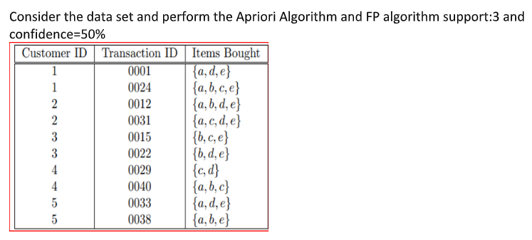
Step 1: Prepare the Dataset
You’ll need to convert the table into ARFF format (WEKA’s native file type). Here’s how your .arff file should look:
arff
@relation transactions
@attribute a {t,f}
@attribute b {t,f}
@attribute c {t,f}
@attribute d {t,f}
@attribute e {t,f}
@data
t,f,f,t,t
t,t,t,f,t
t,t,f,t,t
t,f,t,t,t
f,t,t,f,t
f,t,f,t,t
f,f,t,t,f
t,t,t,f,f
t,f,f,t,t
t,t,f,f,t
Note:
- Each transaction is represented as a set of items.
- You can save this file as transactions.arff.

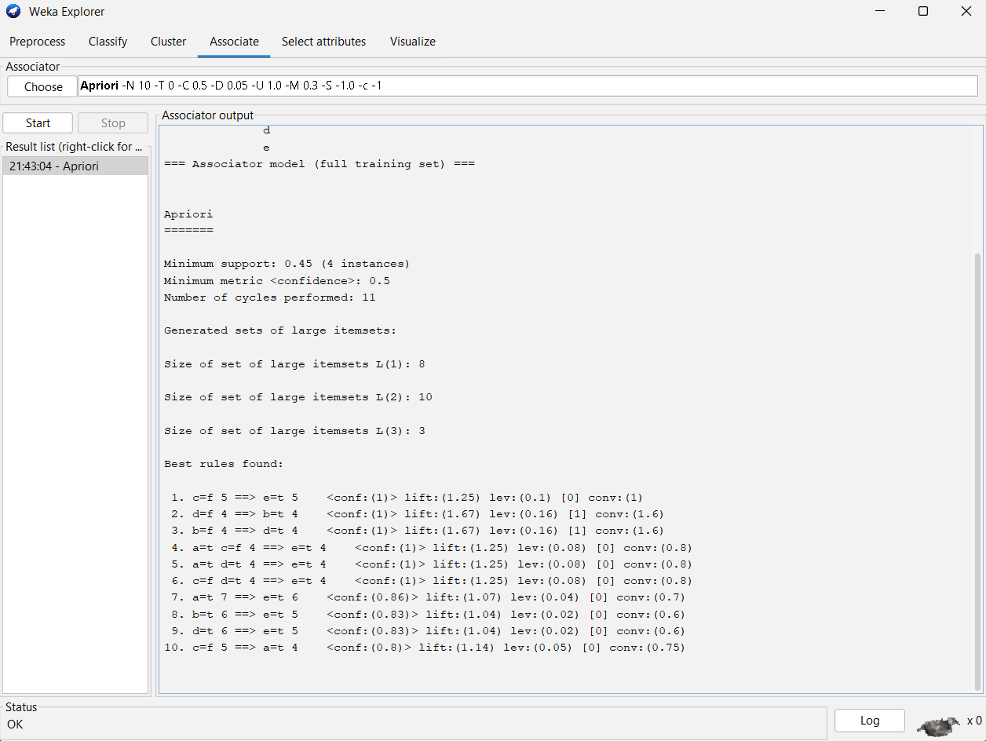

EXPERIMENT 2:
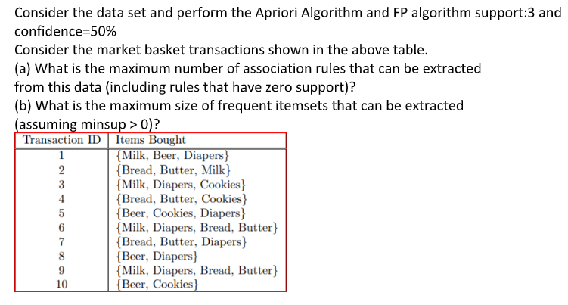
Step 1: Create the ARFF file
You have six items: Milk, Beer, Diapers, Bread, Butter, Cookies. Represent each item as a Boolean attribute (t = present, f = absent).
arff
@relation market_basket

@attribute Milk {t,f}
@attribute Beer {t,f}
@attribute Diapers {t,f}
@attribute Bread {t,f}
@attribute Butter {t,f}
@attribute Cookies {t,f}

@data
t,f,t,f,f,f
f,t,t,t,t,f
t,f,t,f,f,t
f,t,f,f,f,t
t,t,f,f,f,t
f,t,t,t,t,f
t,t,t,f,f,f
f,t,t,f,f,f
t,t,t,t,t,f
f,t,f,f,f,t
Save this file as market_basket.arff.

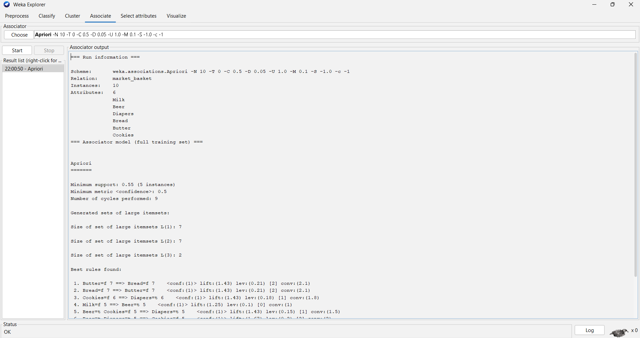
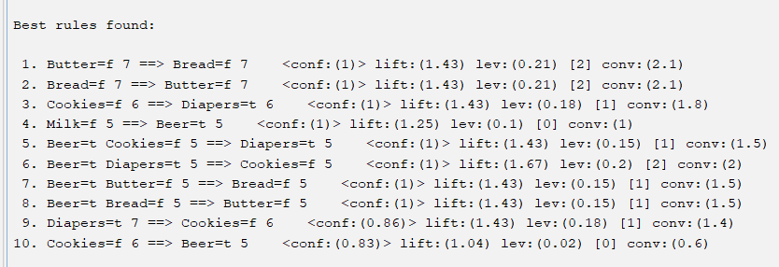
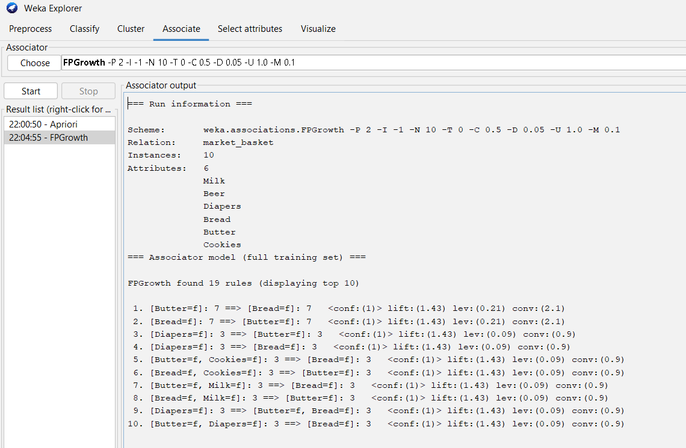

EXPERIMENT 3:
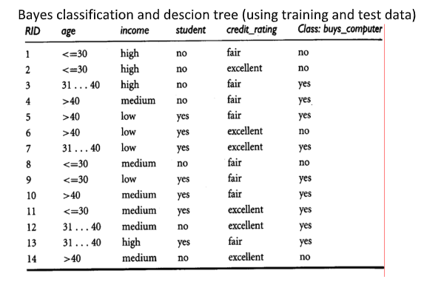
Step 1: Create the ARFF file
Save the following as buys_computer.arff:
arff
@relation buys_computer

@attribute age {<=30,31-40,>40}
@attribute income {high,medium,low}
@attribute student {yes,no}
@attribute credit_rating {fair,excellent}
@attribute buys_computer {yes,no}

@data
<=30,high,no,fair,no
<=30,high,no,excellent,no
31-40,high,no,fair,yes
>40,medium,no,fair,yes
>40,low,yes,fair,yes
>40,low,yes,excellent,no
31-40,low,yes,excellent,yes
<=30,medium,no,fair,no
<=30,low,yes,fair,yes
>40,medium,yes,fair,yes
<=30,medium,yes,excellent,yes
31-40,medium,no,excellent,yes
31-40,high,yes,fair,yes
>40,medium,no,excellent,no

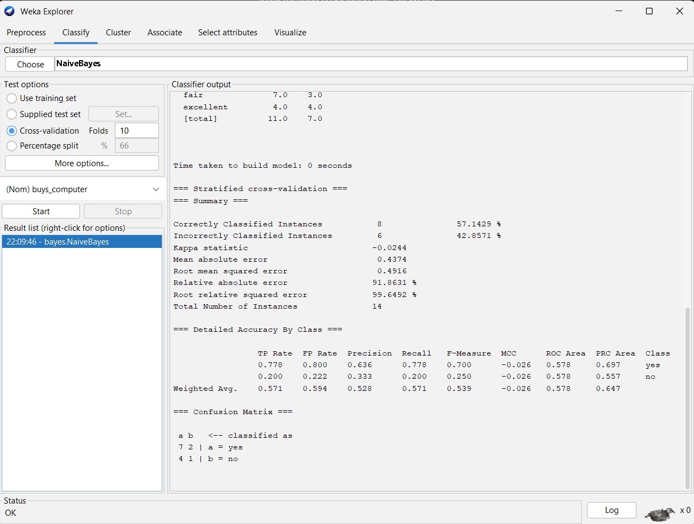
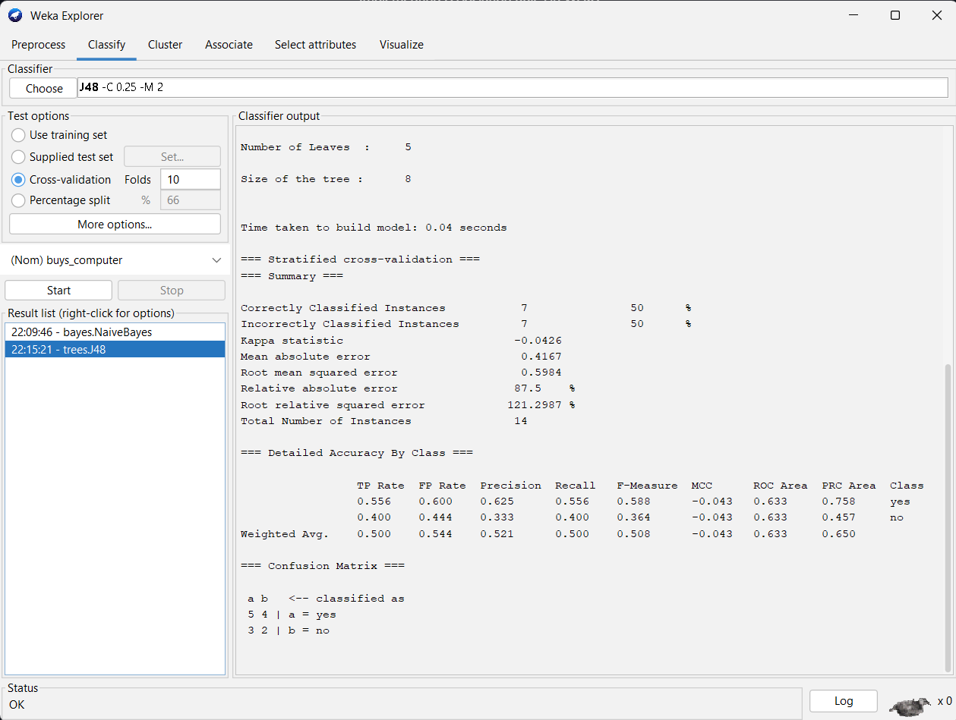
EXPERIMENT 4:
ARFF CODE:
@relation diabetes_trend

@attribute Age numeric
@attribute BMI numeric
@attribute Glucose numeric
@attribute BloodPressure numeric
@attribute DiabetesProgression numeric

@data
25,22.5,130,80,45
30,24.0,140,85,50
35,26.5,150,88,60
40,28.0,160,90,65
45,29.5,170,92,70
50,31.0,180,95,75
55,32.5,190,98,80
60,34.0,200,100,85
65,35.5,210,102,90
70,37.0,220,105,95

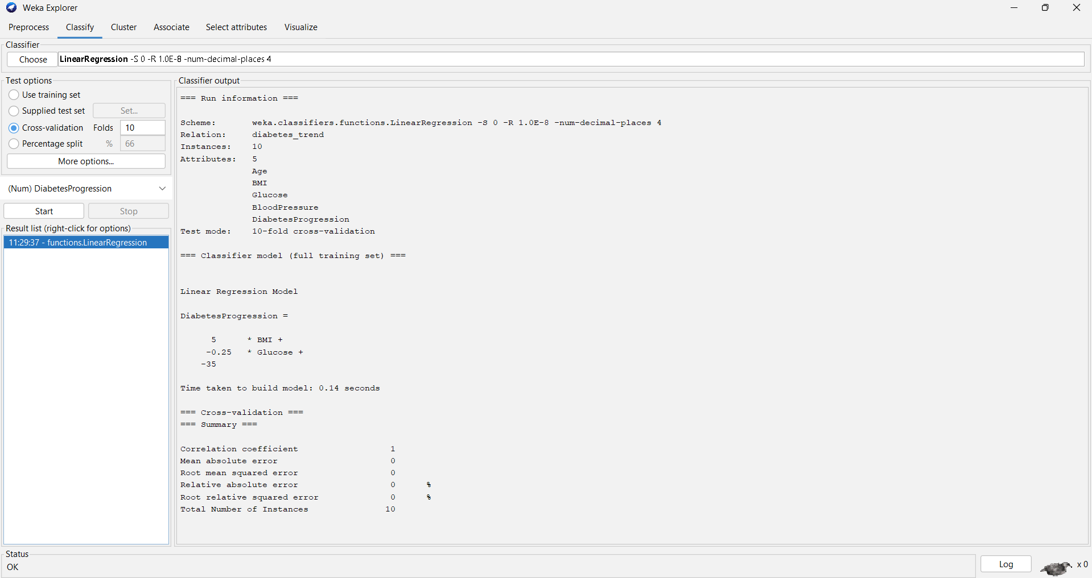
EXPERIMENT 5:
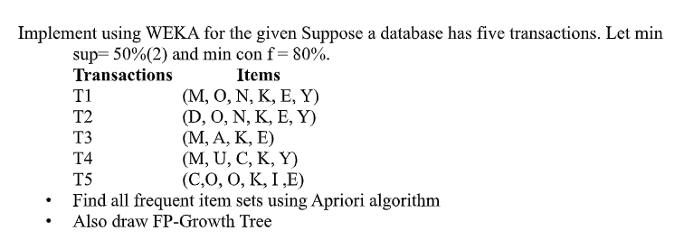
ARFF CODE:
@relation market_basket

@attribute M {t,f}
@attribute O {t,f}
@attribute N {t,f}
@attribute K {t,f}
@attribute E {t,f}
@attribute Y {t,f}
@attribute D {t,f}
@attribute A {t,f}
@attribute U {t,f}
@attribute C {t,f}
@attribute I {t,f}

@data
t,t,t,t,t,t,f,f,f,f,f
f,t,t,t,t,t,t,f,f,f,f
t,f,f,t,t,f,f,t,f,f,f
t,f,f,t,f,t,f,f,t,f,f
f,t,f,t,t,f,f,f,f,t,t
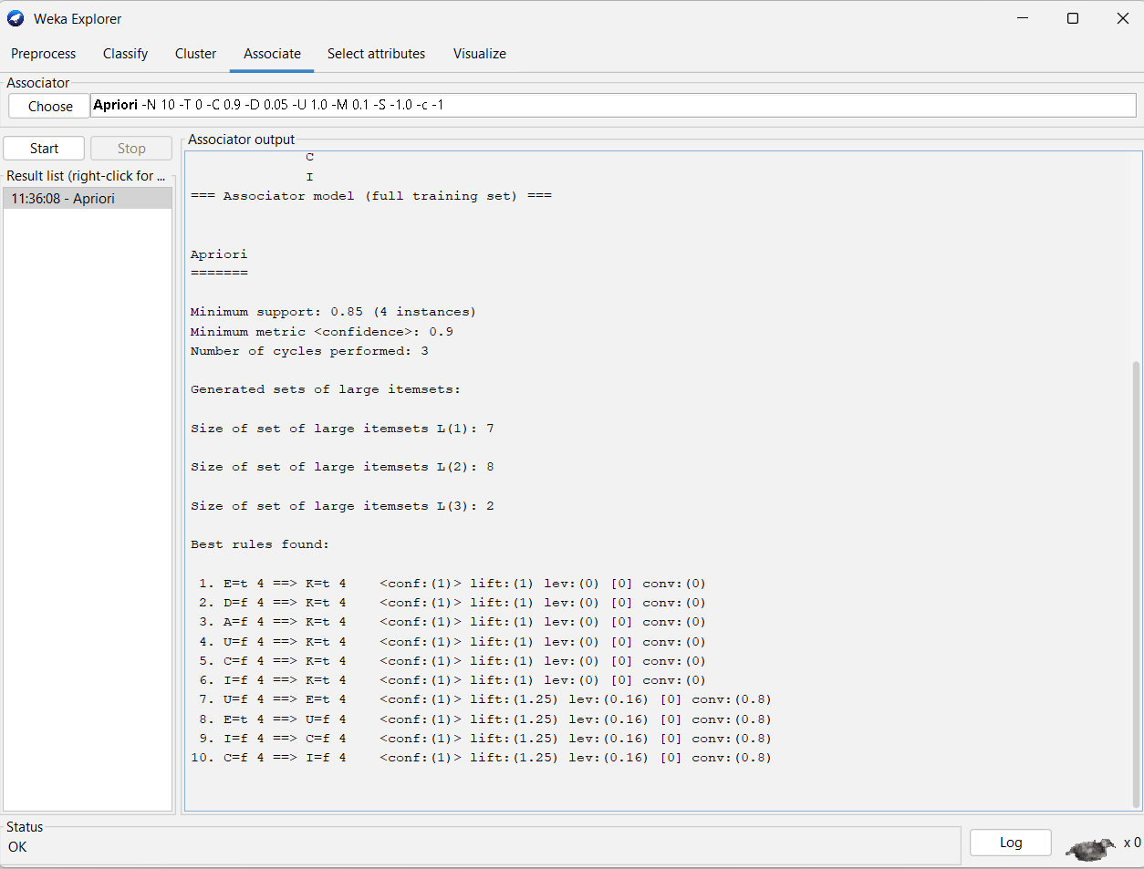
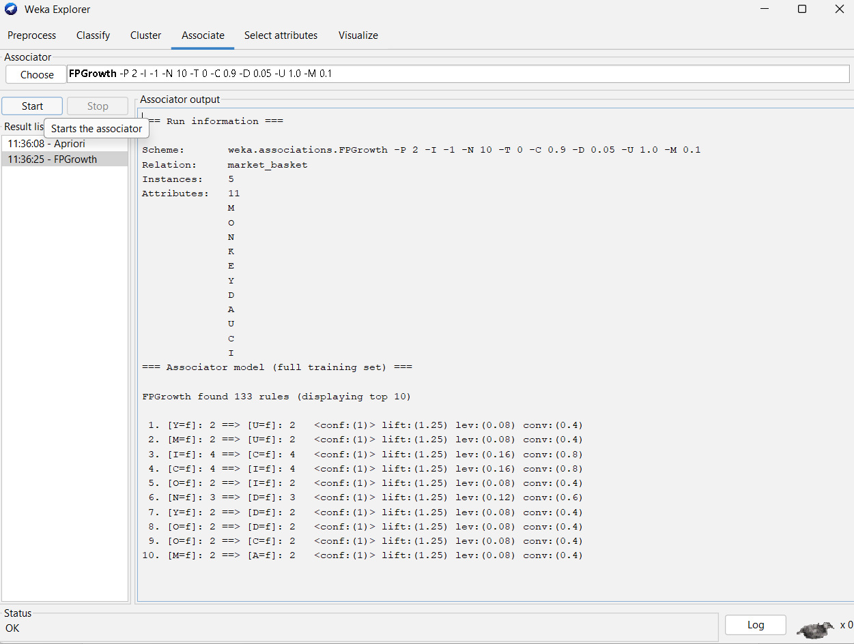

EXPERIMENT 6:
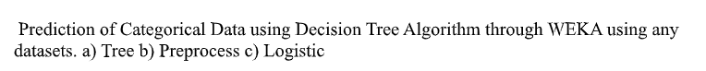
ARFF CODE:
@relation product_purchase

@attribute Age {young,middle,old}
@attribute Income {low,medium,high}
@attribute Buys {yes,no}

@data
young,low,no
young,medium,yes
middle,medium,yes
old,high,yes
old,low,no
middle,high,yes
young,high,no
old,medium,yes
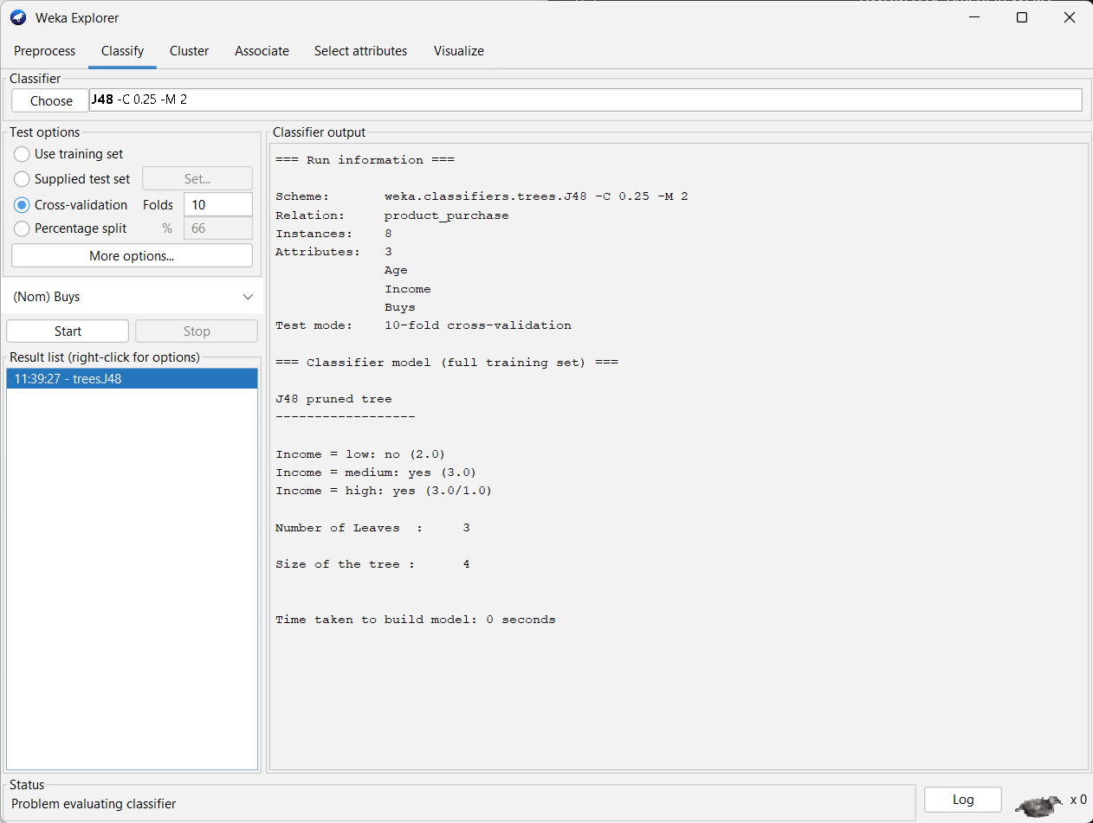
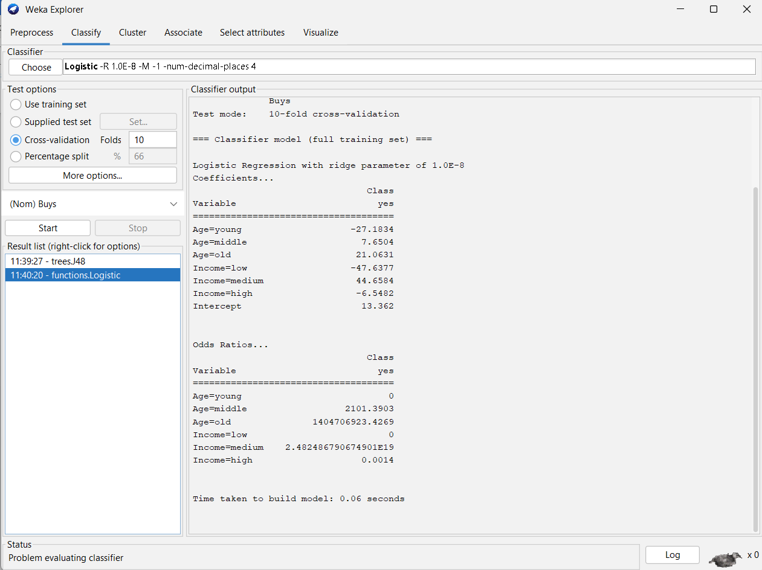
EXPERIMENT 7:
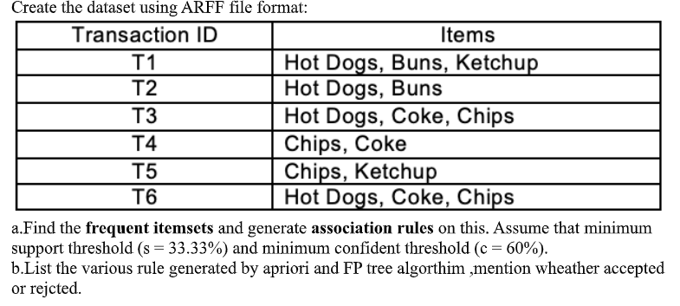
ARFF CODE:
@relation hotdogs_dataset

@attribute HotDogs {t,f}
@attribute Buns {t,f}
@attribute Ketchup {t,f}
@attribute Coke {t,f}
@attribute Chips {t,f}

@data
t,t,t,f,f
t,t,f,f,f
t,f,f,t,t
f,f,f,t,t
f,f,t,f,t
t,f,f,t,t
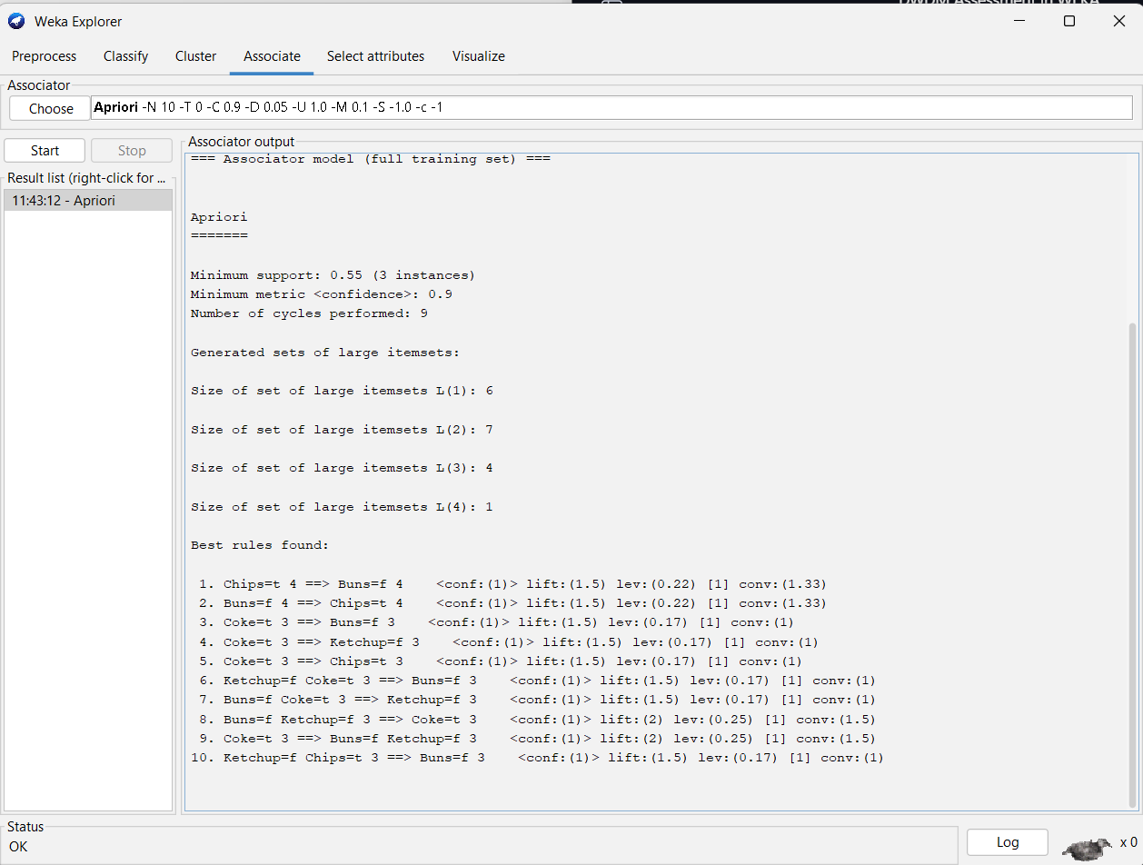
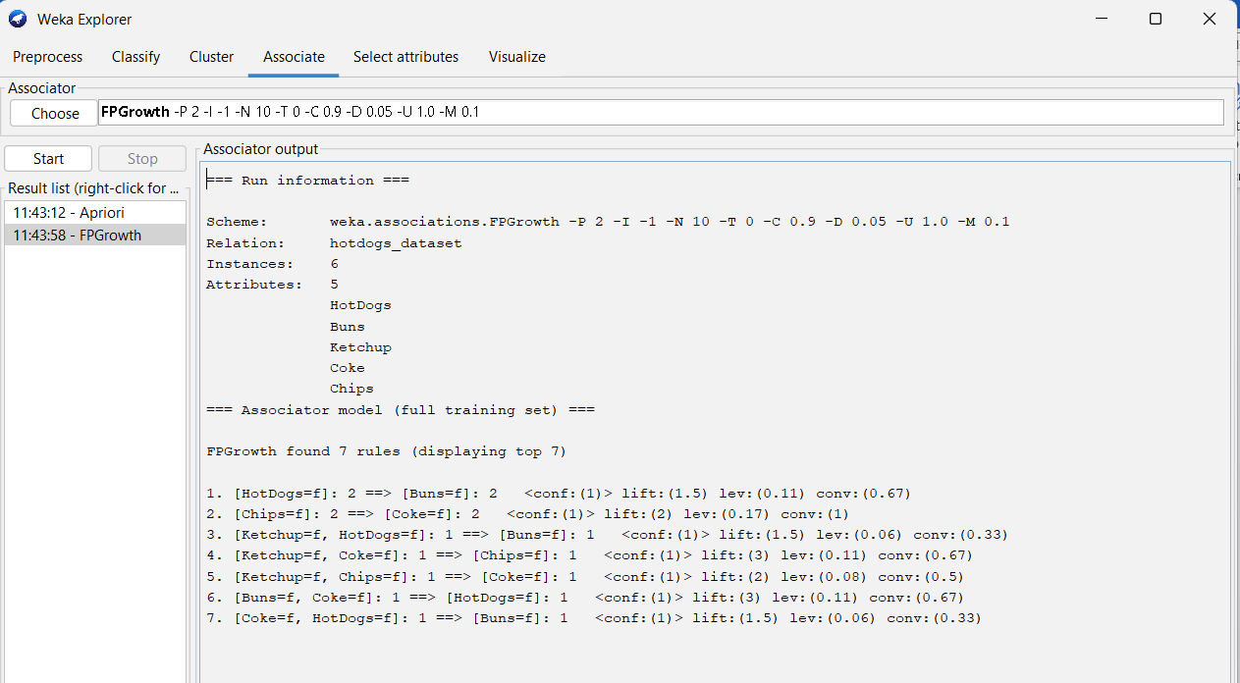

EXPERIMENT 8:
Prediction of Categorical Data using Rule base classification and decision tree classification through WEKA using any datasets. Compare the accuracy using two algorithm and plot the
graph
@relation student_performance

@attribute StudyHours {low,medium,high}
@attribute Attendance {poor,average,good}
@attribute Result {pass,fail}

@data
low,poor,fail
low,average,fail
medium,average,pass
medium,good,pass
high,good,pass
high,average,pass
low,good,fail
medium,poor,fail
high,poor,pass
